SQL project

Query 1: SELECT * FROM "Employee";

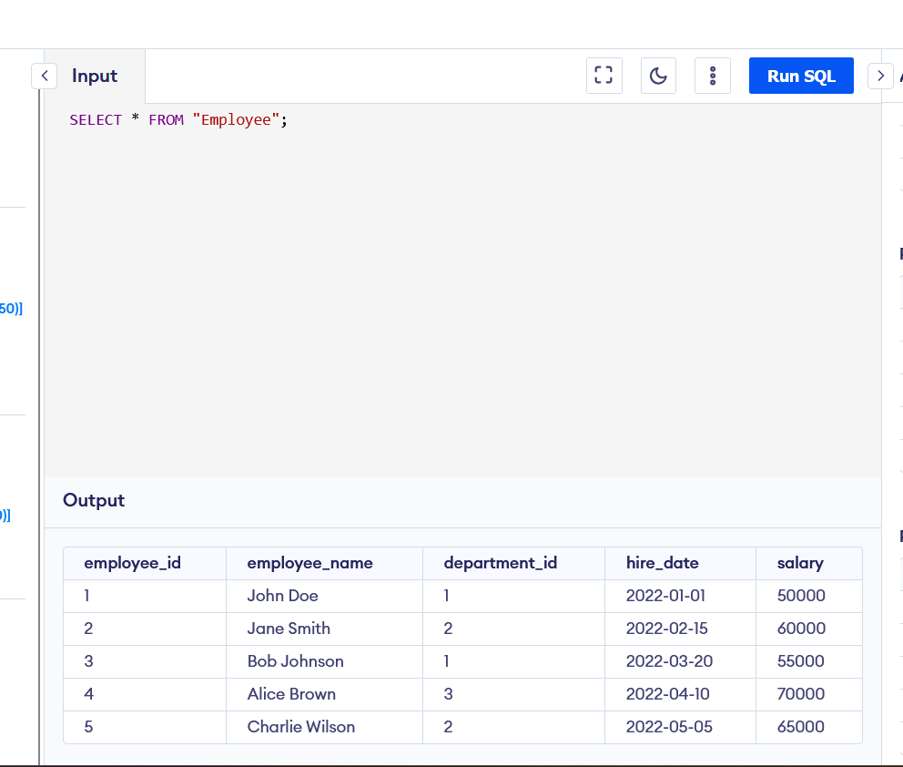Query 2: SELECT DISTINCT "department_name" FROM "Department";

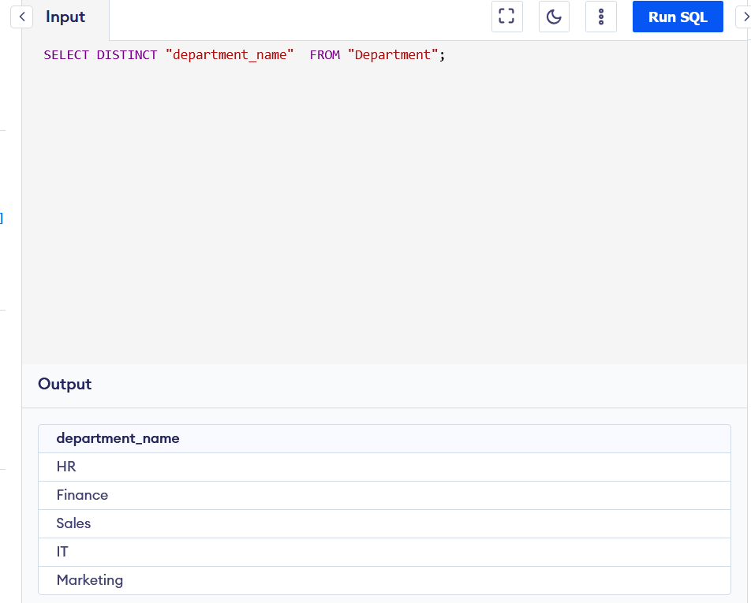

Query 3:

SELECT "employee_name", "salary" FROM "Employee"

ORDER BY salary desc;

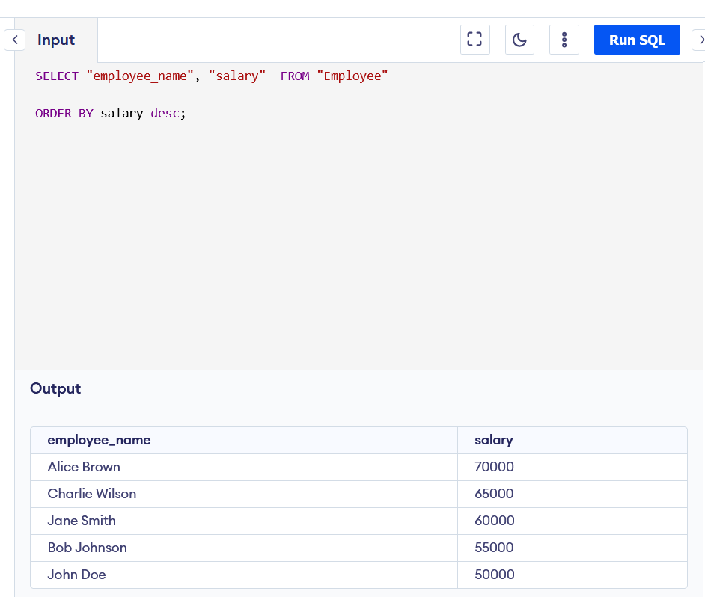

Query 4: SELECT * FROM "Product"

WHERE price <= 500 and price >= 100;

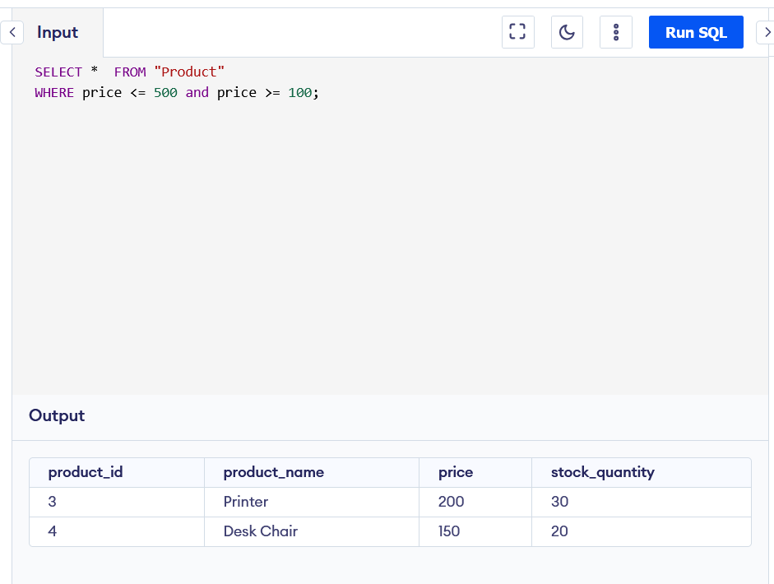Query 5: SELECT Purchase.order_id, Purchase.order_date, employee.employee_name

FROM Purchase

JOIN Employee ON Employee.employee_id = Purchase.employee_id

WHERE Employee.department_id = 3

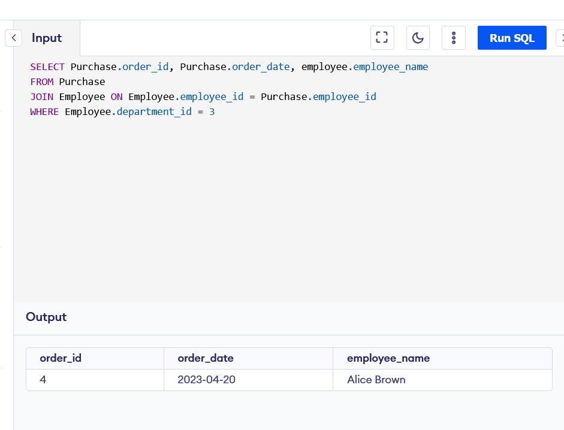

Query 6: SELECT *

FROM product

WHERE product_name LIKE "%chair%"

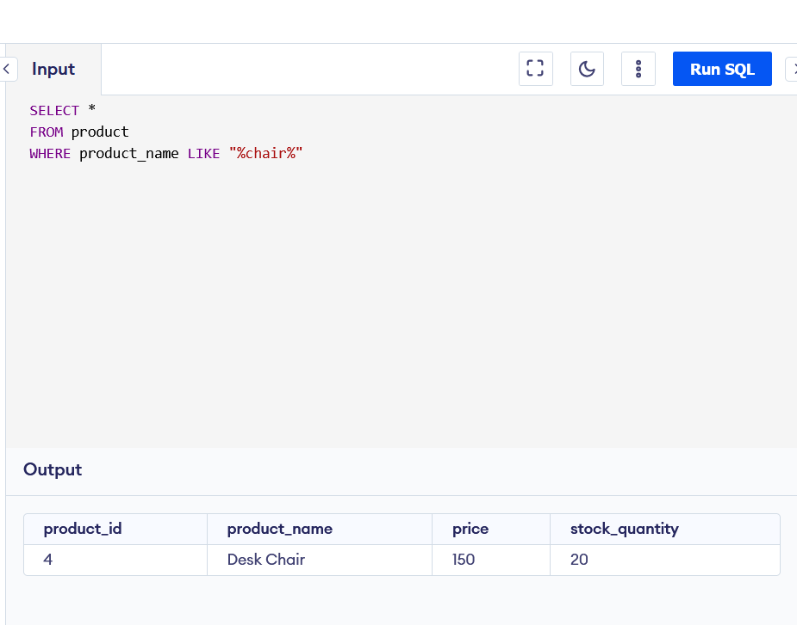

Query 7: SELECT *

FROM purchase

WHERE employee_id = 1 or employee_id = 3 or employee_id = 5

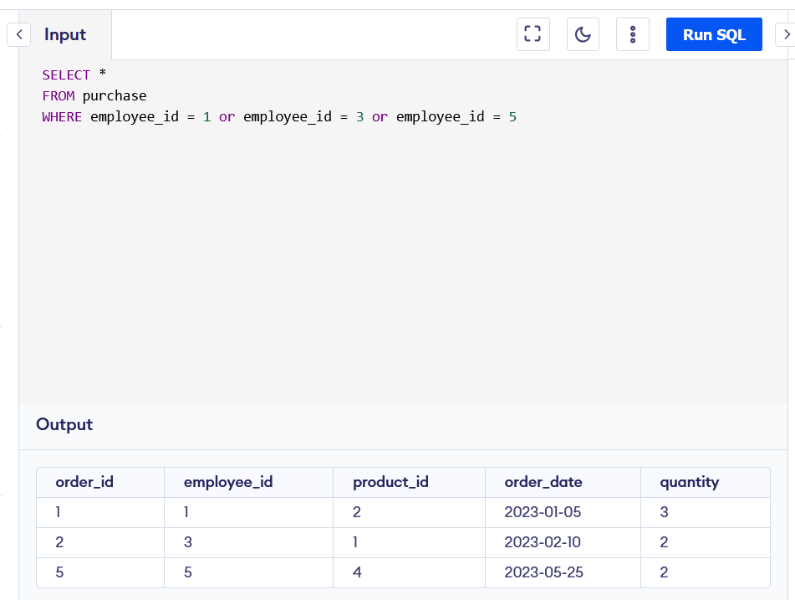

Query 8: select AVG(salary) as average_salery

from employee

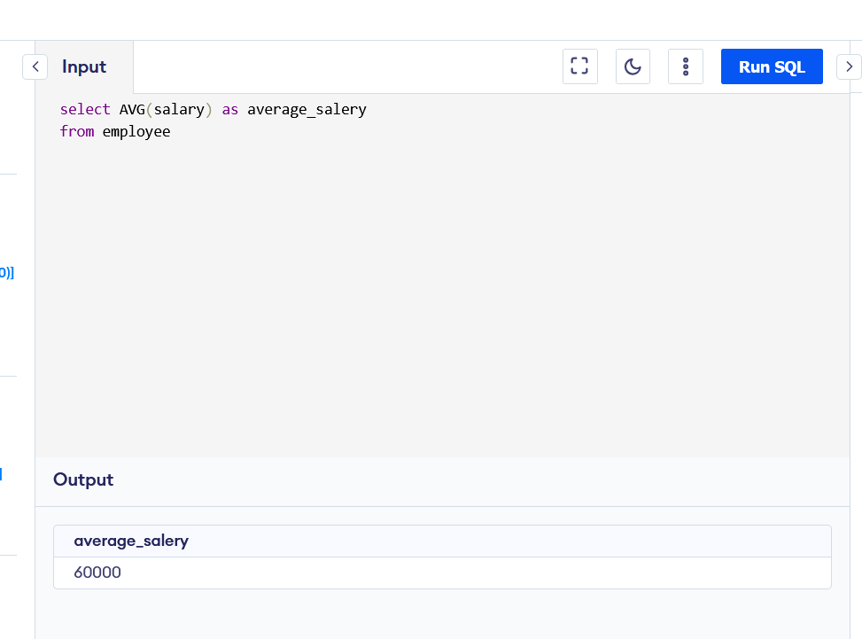

Query 9: select *

from employee

WHERE hire_date > "2022-03-01" and salary > "60000"

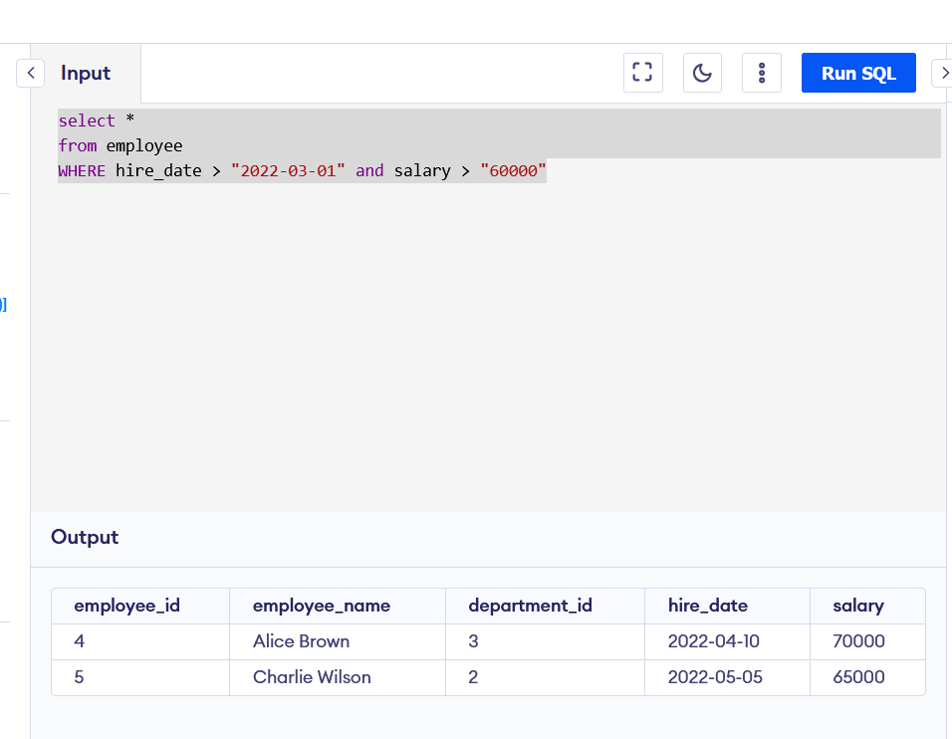

Query 10: SELECT department.department_id, department_name, count(department.department_id) as num_employees

FROM department

JOIN Employee ON Employee.department_id = department.department_id

group by department_name

having count(department.department_id) > 1

